AGENDA of THE PROJECT 4th MEETING
Lifelong Learning Programme’s Grundtvig Partnership project
Fostering Cultural Heritage for Bridging Intergenerational Dialogue
(FOCAL)
www.focalproject.eu
Meeting place: Trakai, Lithuania
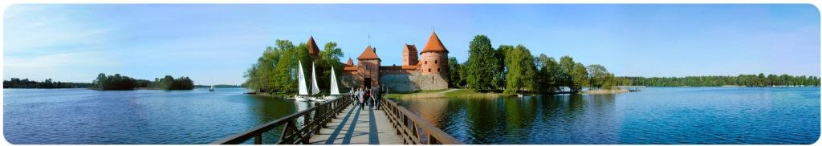
15th of October, 2013
19:00 - … | Arrival day.  Dinner with cultural specialities brought from partners countries.
16th of October, 2013
09:30 – 09:45 | Starting of the meeting with adaptation of agenda and practical information. Review of agenda. By Vida Drąsutė
09:45 – 11:00 | WP2. What did I learn about other countries? What was the most interesting and memorable? (Discussion from analysis of the reports about culture presentation).  Reports could be found at: http://www.focalproject.eu/index.php?mnu=47 .
11:00 – 12:30 | WP3. Presentations of the interviews with seniors “Then and now”.
12:30 – 12:50 | WP8. Project quality and evaluation.  Presentation of evaluation of project reached results and evaluation of the project by target group (learners, external users, etc.) (by Bulgarian partner and discussion by all partners)
13:00 – 14:30 | Lunch with typical Lithuanian cuisine
14:30 – 14:50 | WP7. Presentation of project updated dissemination events (by coordinator)
14:50 – 15:10 | Portals of the project (by coordinator)
15:10 – 15:30 | Coffee and discussions
16:00 – 18:00 | Cultural programme. Depends on the weather.  Sightseeing in Trakai Centre and some history about Trakai, its particularities and Caraims.  Orientation-educational program “PAST BOAT” in TRAKAI Ship VYTINĖ.  This is 45 minutes educational program on the only one Lithuanian commercial vessel “Vytinė”. The ship’s captain will take you to the fifteenth century times: Lessons wicker units, tell you about every detail of the ship. More to the vessel Features specially created a documentary film about the whips in past period in Lithuania …  Gallery: http://www.baltis.lt/photogallery.php?album_id=1 (it is inside the ship, so, you will not get cold, because there is heating too)
18:00 – 20:00 | Free time in swimming pool or SPA ;)
20:00 – … | Lithuanian dinner with Lithuanian folk songs and dances (suggested programme by organizers, we are thinking to invite professional folk programmes organizers)

17th of October, 2013
09:00 – 10:30 | WP4. Presentation of the Contests on theme “The traditional thing which I can represent the best” results
10:30 – 14:00 | Educational programme “Bread way” concerned with Lithuanian traditions and Cultural Heritage.  Lunch – making and tasting the food which has very old traditions and making customs.  (in Trakai region)
15:00 – 17:00 | Educational program "Bees-wax candle manufacturing" (in Trakai)
17:00 – 19:00 | Free time
20:00 - … | Dinner

18th of October, 2013
10:00 – 10:30 | WP1. Project activities timeline (review of the future tasks and project planned results, set the deadlines). Plan of next meeting  (by coordinator and discussion by all partners)
10:30 – 11:00 | WP6. Discussion about the workshops- meetings in groups organizational questions (workshops in local, national levels) with target groups: youth and seniors. Traditions, stories, cultural experience, practical works and creations.
11:00 – 11:45 | Meeting evaluation, certificates, signing list of participants
11:45 – 12:00 | Coffee and discussions
12:00 – 15:00 | Visit to Kernavė (UNESCO object) (~40 km from Trakai) and lunch  http://www.kernave.org/index_en.html
16:00 – 18:00 | Educational programme “Wool felting lessons”
18:00 - … | Free time

19th of October, 2013
Departure day.

